UB Maxx Online Bill Pay Instructions
First, you will need to register. Go to www.ub-pay.com. Click on the member registration. Input the Municipality code of KanopolisKS454. This is case sensitive & has no spaces.
Enter your information as provided on your utility bill.
Once all information has been entered, Click on the register button.
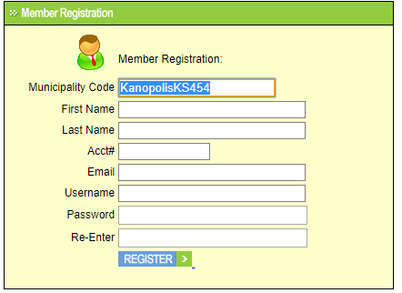

You will then be redirected to login.
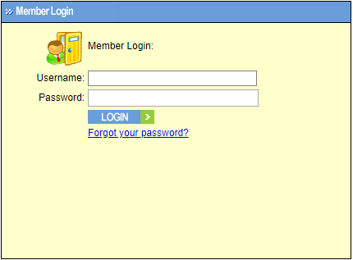
Input your Username & Password. Then click on the LOGIN button.
This is the screen that you will see when logging in.
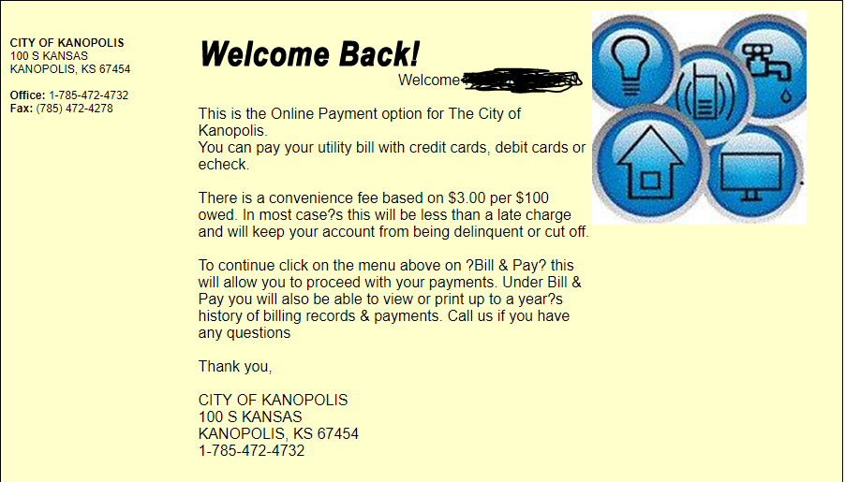
This is what your tool bar will look like.
Click on the Bill & Pay tab.

The next screen will appear as follows:
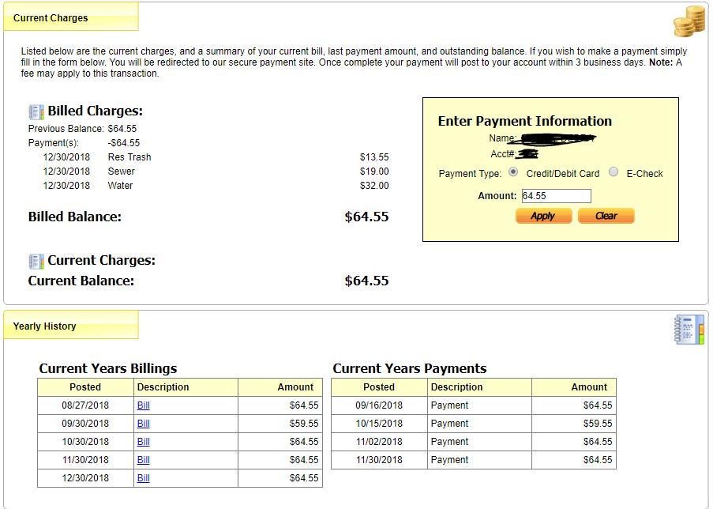
This screen will give previous bills & payments. To pay online, select the payment type of either Credit/Debit Card or E-Check.
If you pay by credit or debit card, you will be directed to the following screen:
You will need to input your email address & click on the I Accept button to continue.
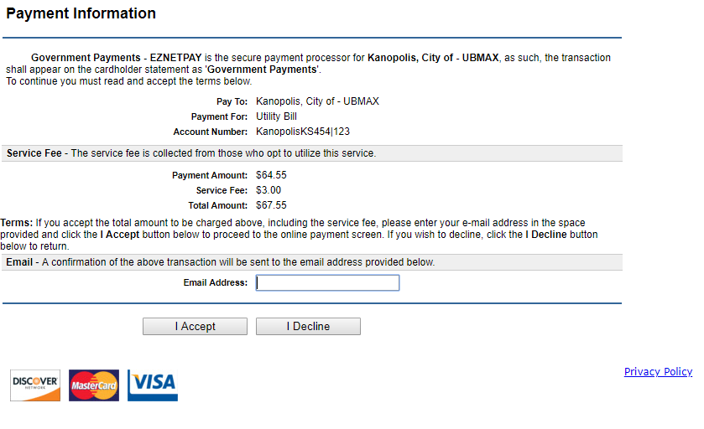
You will then be directed to enter your credit debit card information.
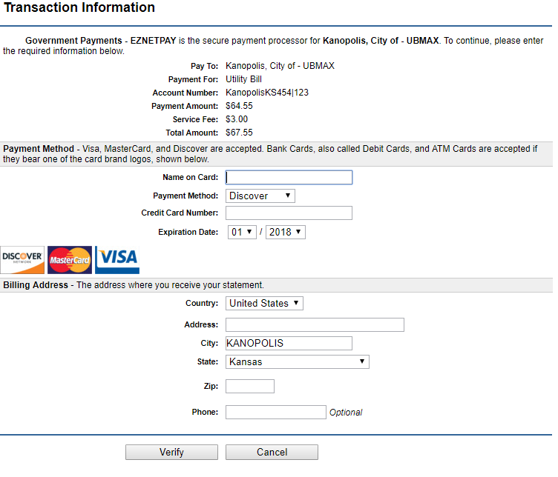
Once everything has been entered, click verify. If everything is correct it should accept the payment. If you get an error, you will need to correct the errors before proceeding.

If you select E-check, you will be directed to input your routing & account information.
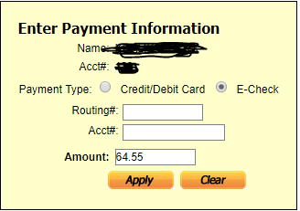
Once entered, click on the apply button.

